NAME _________________________________________ Class Period ____________________

Study Guide DIGITAL photography

- History of digital photography (first digital cameras were low res. and expensive)
(film and digital are just the way a picture is recorded)
(George Eastman - Kodak - first affordable film camera) (Sony Mavica - Magnetic Video Camera)

- Careers in photography

3. Focal plane curtain shutter (time and light) (shutter speeds - how long the camera is active)

4. A leaf (iris) shutter (fractions of light - through the lens aperture) Aperture and depth-of-field

5. Zooming: 3x 4x 10x 12x

6. Digital and optical zoom (telephoto effect)

7. SLR (Single Lens Reflex and Point & Shoot cameras)

8. Lenses (zoom) (prime)

9. Camera modes

10. ISO

11. Grain and Noise

12. White balance

13. Cropping photos

14. Tripods and Monopods (three legs and one leg)

15 Digital contact or proof sheets (Larger photo with small thumbnails on it)

16. Action photography and freezing or blurring action. (fast shutter speed = freeze action)
(slow shutter speed = blurred action) (fast shutter needs more light) (slow shutter speed = less light)

17. Size of digital files (fine, extra fine, standard, etc.)

18. Flash photography and red eye

19. Resolution = 72 ppi vs. 300 dpi (72 digital & 300 printing such as an 8x10 print size or better)

20. Kinds or format of digital files RAW JPEG PNG

21. Memory cards SD, CF, XD, Memory Stick (SONY), Smart Media (not photo cards) (images are stored on card)
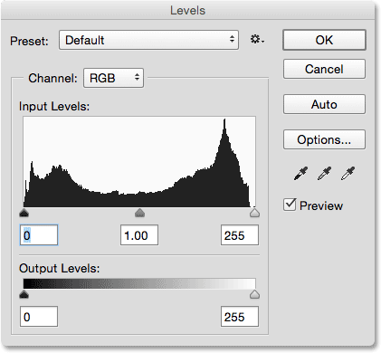
22. Portfolio (compilation of your best work)

23. Storing, editing and printing

24. Organization that competes and leads in photography (SkillsUSA)

25. Composition rules

26. Pixels and Pixilated

27. Histogram

ADOBE PHOTOSHOP

28. LAYERS - (making a new layer places it just above the layer you are on) & Opacity of layers

29. Undo = the history
a. One step at a time is Cntrl/z and Cntrl/alt/z is another step back in history

30. Shortcuts in Photoshop
a. Brackets make brush sizes bigger.
b. Right clicking gives many options

31. Photoshop tools:
a. Lasso (selects any shape of pixels) (selection tool)
b. Polygonal Lasso (selects pixels in multi-sided straight lines) (selection tool)
c. Marquee (rectangles, squares, ovals, circles) (selection tool)
d. Crop (select size and resolution)
e. Text (makes type)
f. Clone stamp (selects or duplicates pixels)
g. Magic wand (color related pixels) (selection tool)
h. Eye dropper (sample colors)
i. Dodge (lightens) and Burn (darkens)
j. Levels (changes contrast, lightness & darkness)
k. Brush / pencil [ bracket keys ] (makes any active tool larger & smaller)
l. Zoom tool (makes your photo smaller and larger)

32. HUE = the actual color and SATURATION = color intensity

33. Drawing and painting lines = hold down shift to draw straight lines

34. Point and shoot and DSLR

35. The shutter button (focuses and meters the lens and camera)

36. Mega pixel (1,000,000 - 1 million)
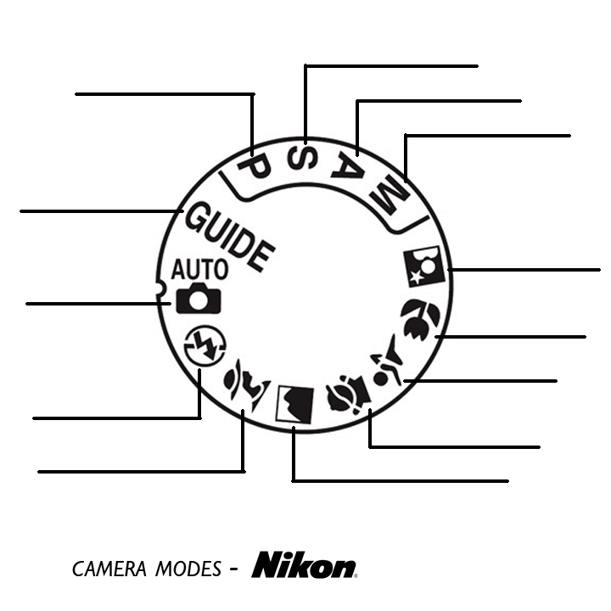
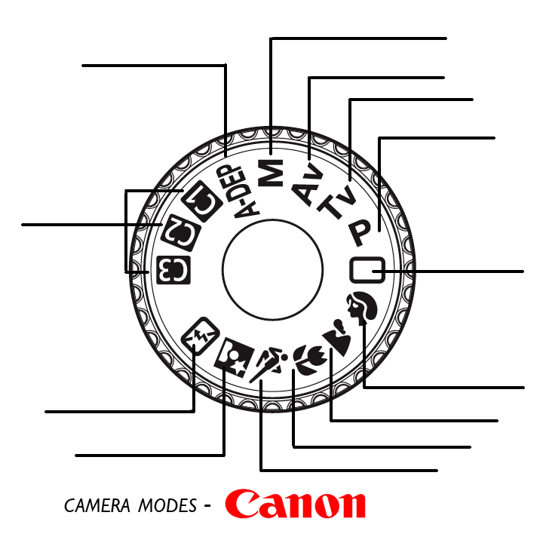
37. Work Flow (capture, edit, output)

